Canfield High School Website:

Please take time to view the Canfield High School website at
http://www.canfield.access-k12.org/ to view up-to-date information on what is going on in your school. The website is a great resource.

Important Dates to put on your calendar:

October 5, 2019 – Homecoming Dance 7-10 p.m. at CHS

December 7, 2019 – Senior Craft Show (Seniors who work a four-hour shift will get their cap/gown/tassel paid for)

February 8, 2020 – Sweetheart’s Dance

February 20, 2020 – Senior pictures due to Mr. Graff @ https://pgraff5.wixsite.com/mrgraffcg2014/yearbook

April 10-17, 2020 – Spring Break

May 9, 2020 – Prom

May 26, 2020 – Junior/Senior Banquet

May 27, 2020 – Senior Breakfast

May 29, 2020 – Graduation

If you have any questions regarding the Senior Craft Show, Sweethearts, Junior/ Senior Banquet or Graduation, please contact Mr. Holben (aholben@ canfieldschools.net) or Mrs. Reed (ckreed@ canfieldschools.net)

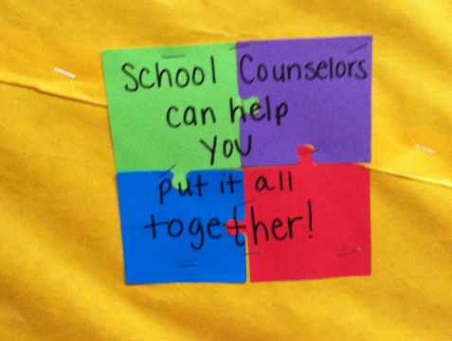

Earlier in the school year, a letter was sent home to all senior parents which included the student’s transcript. Please make sure you have taken a look at the transcript to ascertain that all is correct. If not, please contact your school counselor immediately.

College Entrance Tests

Seniors may elect to retake the ACT or SAT this fall. Taking the test a second time could help if students need higher scores for admission or scholarship consideration.
SAT subject tests are subject area achievement tests and should only be taken if required for admission by your college.

Register on-line for SAT at www.collegeboard.com and for the ACT at www.actstudent.org. When you register, the “CEEB” code for Canfield is 360750.

Canfield High School is a test site for the ACT. Our test center code is 216990.

Most colleges, universities and NCAA require the scores be sent directly from the testing agency. It is the responsibility of the student to have scores sent. This can be done at the time of registering for a test and specifying the colleges that should receive scores, or at a later date by requesting submission through the testing agency.

NCAA Clearinghouse

If you want to play NCAA sports at a Division I or II school, you need to register for a Certification Account with the NCAA Eligibility Center. College-bound student-athletes in Division III can also create a Profile Page to receive important updates about being a student-athlete and preparing for college. Students who are not sure which division they want to compete in can create a Profile Page and transition to a Certification Account if they decide to play Division I or II sports.

The NCAA Eligibility Center works with you to help you prepare for life as a student-athlete. If you have questions about your eligibility or the registration process, please review http://www.ncaa.org/ or call NCAA toll free at 1-877-262-1492.

If you are working on college applications, make sure you do not miss your deadlines. For example, Ohio State’s early application deadline is November 1st. You should not wait until October 31st to submit!!

Also, all ACT scores should be sent directly to colleges at least one week prior to the applica-tion deadline to assure they arrive in time. It is the student’s responsibility to know if the college they are applying to needs the ACT results sent directly from ACT or if they will take it from your high school transcript.

Remember, you must give counselors at least ten days to complete your applications.

September
- Mark your calendar with registration, admissions, and financial aid deadlines and fees.
- Create separate folders for each of the schools that interest you and keep the materials organized.
- Begin writing drafts of your college essays.
- Start completing early admission college applications.
- Meet with school representatives who visit CHS.
- Look at virtual tours of college campuses online.
- If you want to retake the SAT and/or ACT, register for the test(s).
- Attend college planning and/or financial aid information nights and college fairs.
- Set up your FAFSA ID (and your parent will need one, too) and start gathering information so you can complete the Free Application for Federal Student Aid (FAFSA) as early as October 1.
October
- Take the SAT and/or ACT.
- Continue working on your admissions essays.
- If you haven't already done so, sign up for an FSA ID, to complete your FAFSA online. (Also let your parents know that they will need an FSA ID.) Make sure to protect your FSA ID and keep it in a secure place so that you will have it later when you need it. Keep copies of all financial aid and enrollment documents in a file.
- Contact the U.S. Department of Education at 1-800-4FED-AID or 1-800-433-3243 for assistance completing the FAFSA
- Complete your FAFSA online to determine your financial aid eligibility.
- Watch for the e-mail notice indicating your Student Aid Report (SAR) is ready.
- Review your SAR for errors and make any corrections as indicated.
- Attend college planning and/or financial aid information nights and college fairs.
- Visit your top school choices. If possible, make appointments with faculty, staff, and students.
- Contact the schools' financial aid offices to determine which forms they require. Some schools may require special forms.
- Finalize portfolios, audition tapes, writing samples, or other evidence of talent if required for admission.

